**Project Design Document (PDD)**

**Autonomous Coffee Machine**

**Author: Scott White**

**Date: 10/23/2017**

**Revision 1 Date: 12/04/2017**

**Revision 2 Date:**

**Revision 3 Date:**

**Project Design Document_______________________________________3**

1. **Architectural Design_________________________________________________3**
2. **Hardware Design_____________________________________________________6**
   1. State Flow Diagrams___________________________________________________________6
   2. Schematics______________________________________________________________________7
   3. Timing Diagrams_______________________________________________________________8
   4. Theory of Operation___________________________________________________________9
3. **Software Design______________________________________________________9**
   1. Static Design____________________________________________________________________9
   2. Functional Design____________________________________________________________10
   3. Dynamic Design______________________________________________________________10
4. **Glossary______________________________________________________________10**
5. **Appendixes__________________________________________________________11**
6. **Architectural Design**

The architectural design requires me to build a physical coffee machine that can support multi-cup brewing, two different brews without needing the filters to be cleaned, and remote control accessibility. Being that I am not a mechanical engineer, I decided to take a pre-existing coffee machine and alter and add some components to fit my needs. The machine I currently am trying to prototype with looks like this.

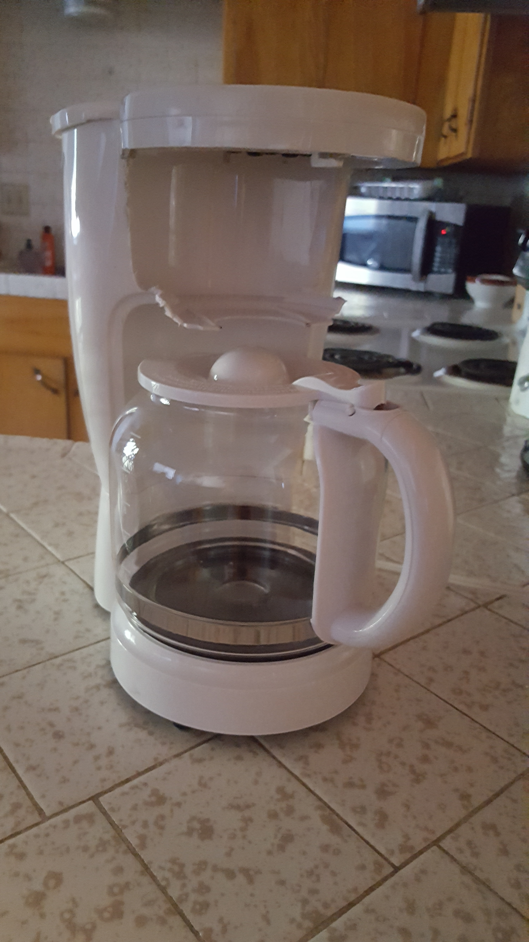

One of the primary components that I need is a carousel that will spin two filters around so the coffee machine can brew three separate times without needing to be cleaned. This is the design for the carousel I will use.

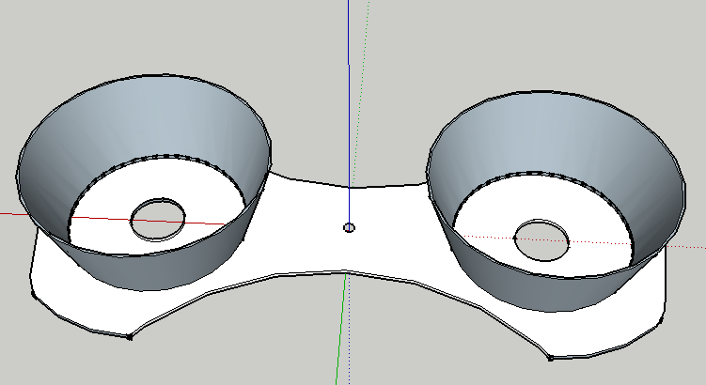

I am also needed to design a shaft for the motor to spin the carousel 200 mm above the counter. For this I used a 130mm M6 all thread rod coupled with an RC airplane motor connector that connects to the DC motor. This is what it looks like.

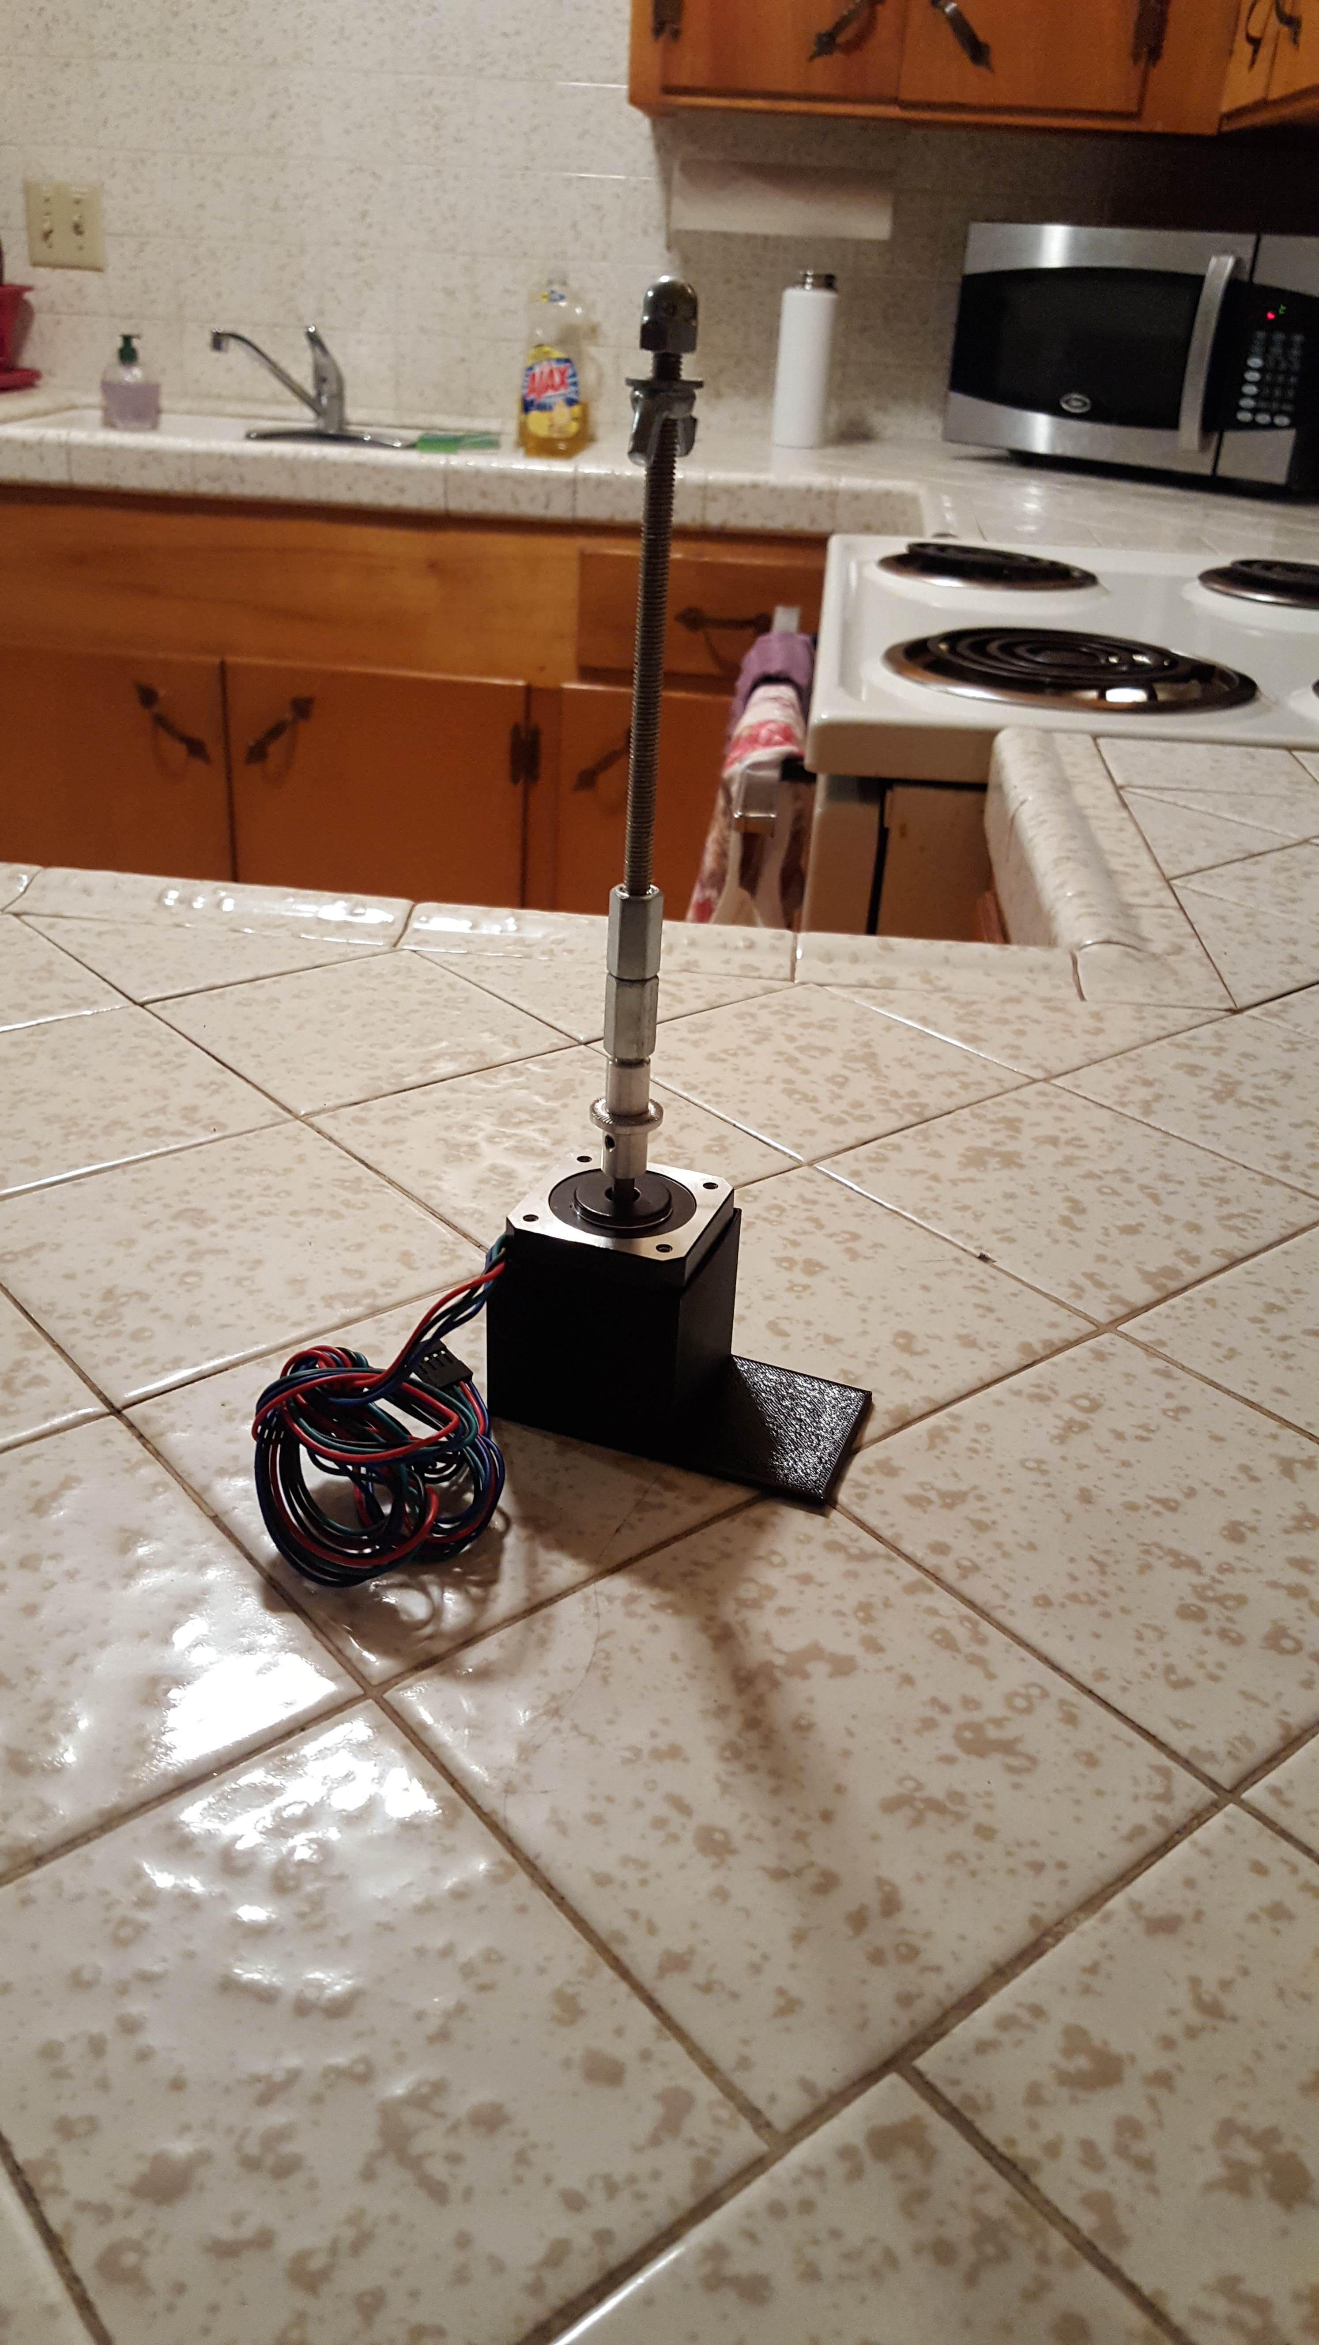

I also needed a means to connect the stepper motor to the coffee machine to keep it from moving, so I designed this motor mount.

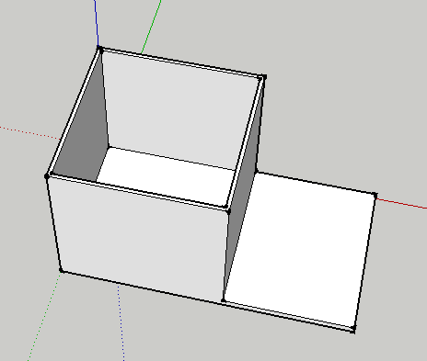

I am now working on designing a reservoir for water and coffee grounds that can support at least two brews, as well as some sort of device to mount the reservoirs. After I finish the mechanical design for the physical machine I have to build an enclosure for the power supply, but I will add details when I get to that part.

1. **Hardware Design**
   1. **State Flow Diagrams**

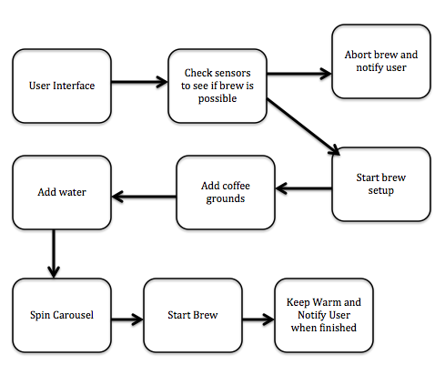

* 1. **Schematics**

Solenoid Schematic

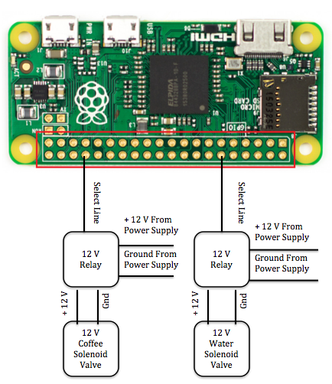

Motor Schematic

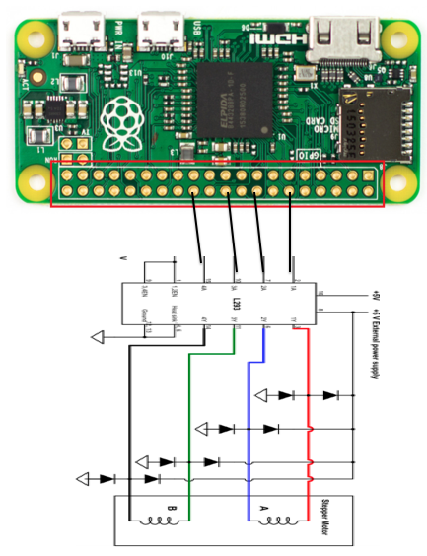

Sensor Schematic Coming Soon

Power Supply Schematic Coming Soon

* 1. **Timing Diagrams**

It is too early for me to have any timing diagrams, but after I do testing I will have timing diagrams for how long to open the coffee and water reservoir valves to let the appropriate amount of coffee in. I will also have timing diagrams for how long it takes to brew different size pots and how long the pot warmer will stay on.

* 1. **Theory of Operation**

The user will open up my webpage, which will have a user interface to start a brew with selectable parameters. When the user starts the brew, the machine will be triggered to run and passed the user’s parameters. The machine will first check if there is a clean filter to brew with. If so the machine will continue and if there is not the machine will abort and send a message back to the client reporting that it could not brew until the filters were cleaned. Before starting the brew, the machine will add coffee into the filter based on how many cups and how strong the user wanted their brew. The machine will then add water to the reservoir based on how many cups the user wanted to brew. The machine will then spin the carousel into place and start the brew. Once the brew is finished the machine will keep the coffee warm for a set amount of time.

1. **Software Design**

**3.1 Static Design**

The coffee machine will keep all pots of coffee warm for the same amount of time after the brew has finished. The user interface will be static unless an error occurs. All of the autonomous brewing functionality is dynamic because it changes with the user parameters, but the basic functionality will be the same for all brews.

**3.2 Functional Design**



**3.3 Dynamic Design**

The software will be dynamic in that it will decide whether it can start a brew based on if it has sufficient supplies and a clean filter to set up. It will also be dynamic in that the machine will be brewing different volumes of coffee and different strengths of brews. The user interface will also be reporting to the user when errors occur or when a brew finishes.

1. **Glossary**

Solenoid Valve: An electromechanically operated valve.

Relay: Switches that open and close circuits electromechanically or electronically.

1. **Appendixes**